# LAB # 14

**Introduction to GitHub**

**OBJECTIVE**

Performing commit, push, and pull operations from eclipse repository and analyzing version changes on Git repository.

# Lab Task:

Create account on GitHub, add a clone git repository in eclipse and push the java project on GitHub

**Create a Project in Eclipse.**

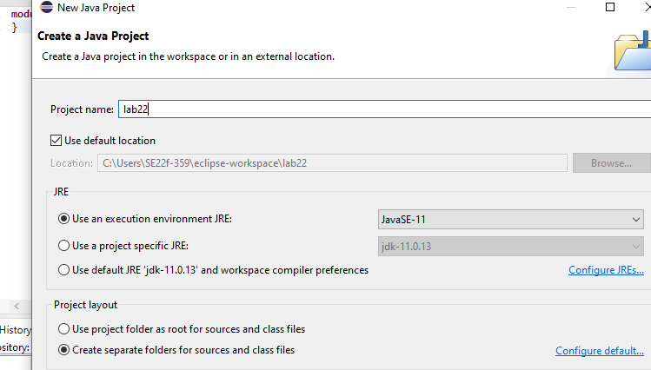

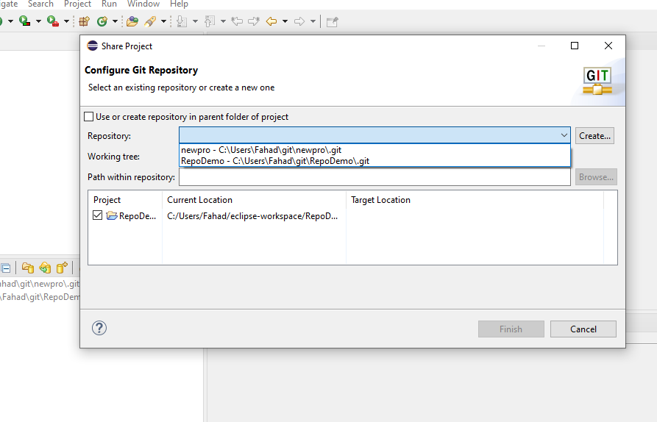

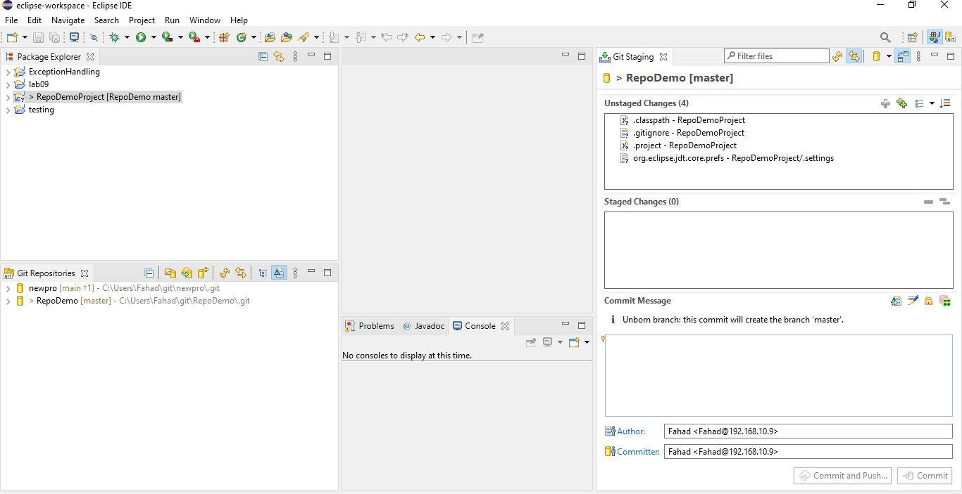**Commit and Push the project to the repository.** 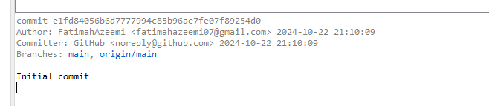

**enter finish.**

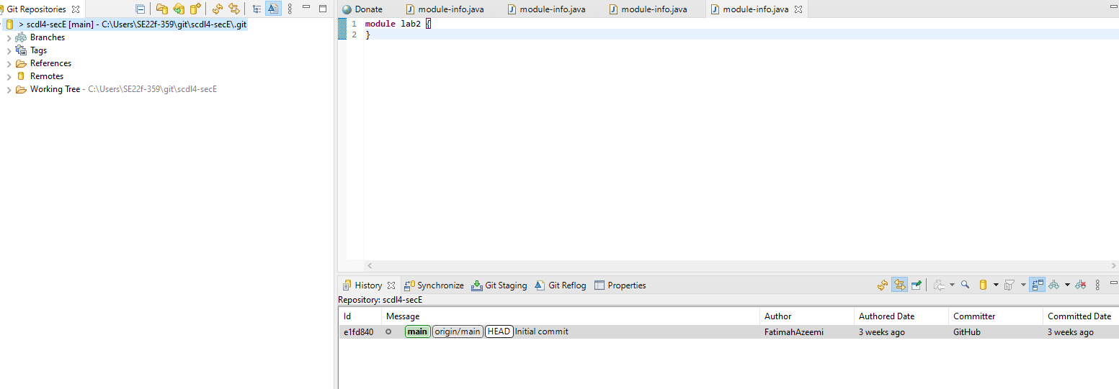

Enter Push.

Refresh GitHub, now you can see your project their in the repository you created.

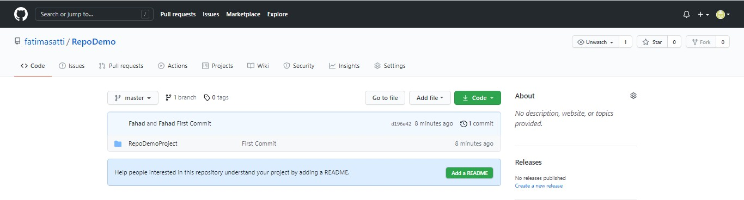

**Adding classes.**

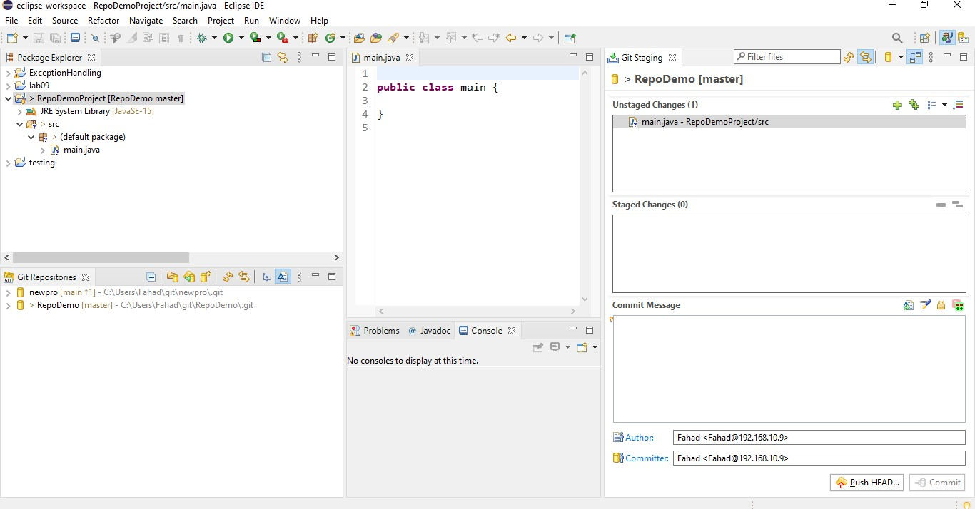

**Drag and drop files from Unstaged changes to staged changes, write some commit message and enter commit and push.**

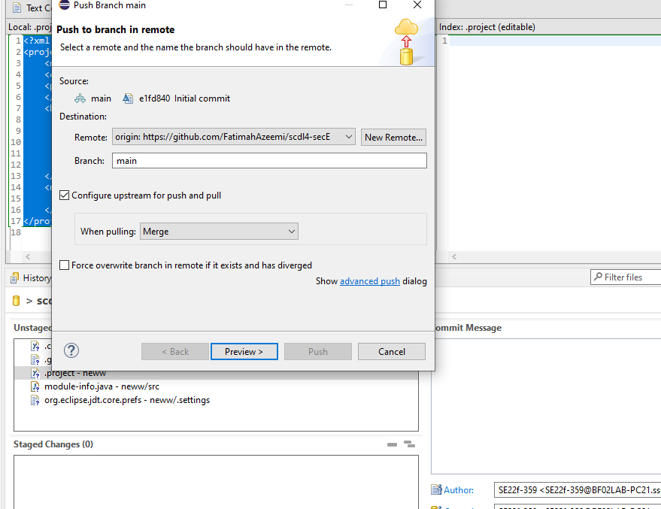

Go to GitHub, refresh your page.

